F 241 MPI - Mid-Semester Report

1. Team Name: Group X
2. Team Lead: Priyansh Aryan
3. Members :

|  |  |  |  |
| --- | --- | --- | --- |
| **S.No:** | **Name** | **Email ID** | **Mobile Number** |
| 1 | Priyansh Aryan | f20180428@hyderabad.bits-pilani.ac.in | 9795155000 |
| 2 | Abhik Santra | [f20180612@hyderabad.bits-pilani.ac.in](mailto:f20180612@hyderabad.bits-pilani.ac.in) | 7224950498 |
| 3 | Sneh Lohia | f20180171@hyderabad.bits-pilani.ac.in | 8789023171 |
| 4 | Mehul Chandwani | f20180488@hyderabad.bits-pilani.ac.in | 7607802731 |
| 5 | Shubhesh Tiwari | f20180478@hyderabad.bits-pilani.ac.in | 7703012618 |
| 6 | Prateek Sinha | f20180374@hyderabad.bits-pilani.ac.in | 7815977675 |

1. **Project Title :**

**“Arduino based navigator for differently-abled person”**

1. **Description of Work Carried Out Till Date : (10)**

As of now since because of unavailability of our previous project we had to shift to a new project which is as mentioned in the title.

So as of now we are working and improving our skills in coding by learning Arduino and we have prepared several design of different sensors we will be using, we learent about them and learnt physical application of these different sensors

In this project we shall be mainly using 5 different types of sensors namely:

**Ultrasonic transducer,fire sensor, IR sensor, water sensor,light sensor.**

Out of these sensors we have made the circuits for ultrasonic transducer,light sensor as well as IR sensors we have also developed codes for these following sensors. We have used a breadboard to connect different components to the Arduino board.

The circuits of different sensors has been attatched:

**Transducer:**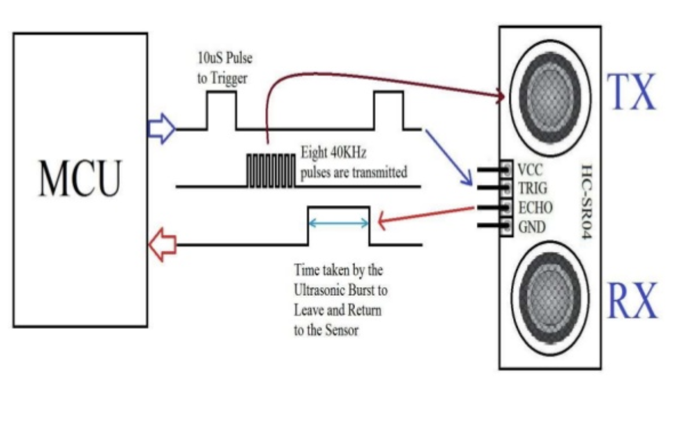

**IR sensor:**

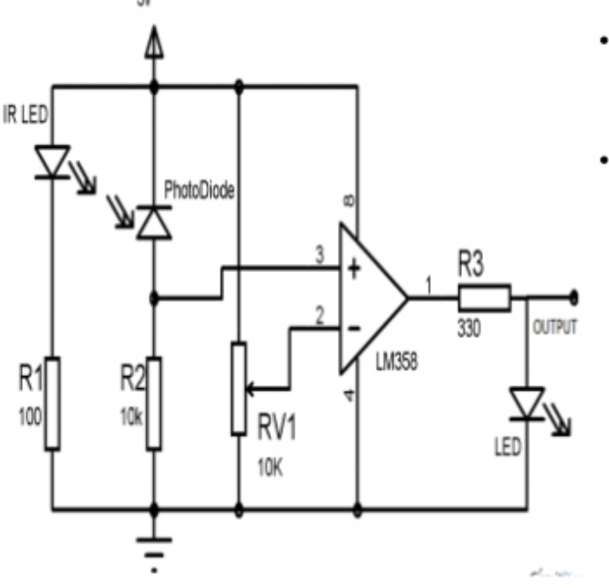

**Fire sensor:**

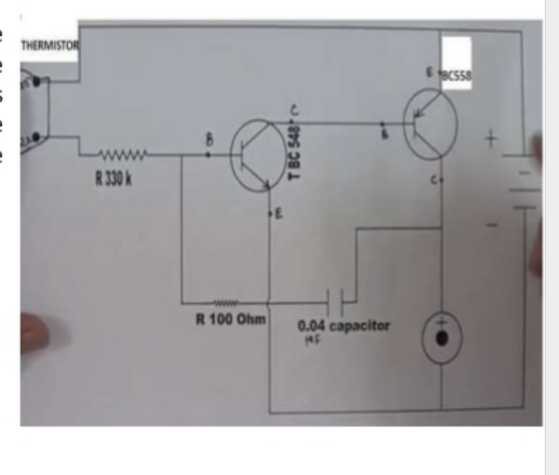

**Water sensor:** 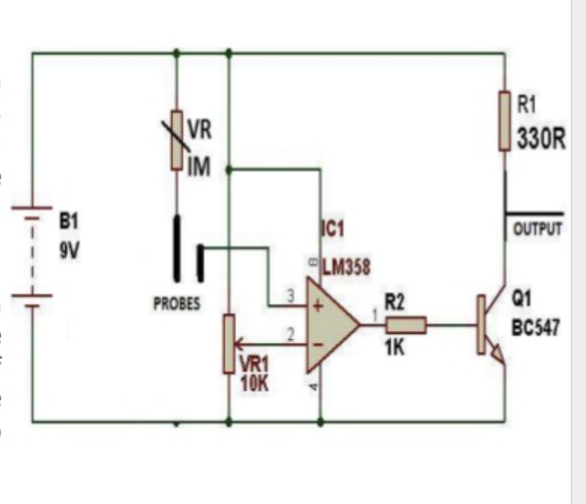

**Light sensor:**

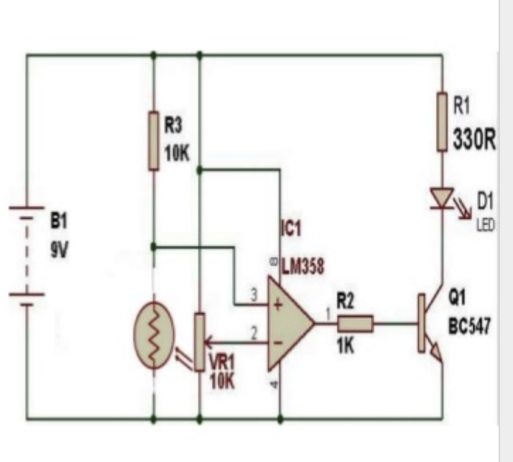

**Global Positioning System Module**

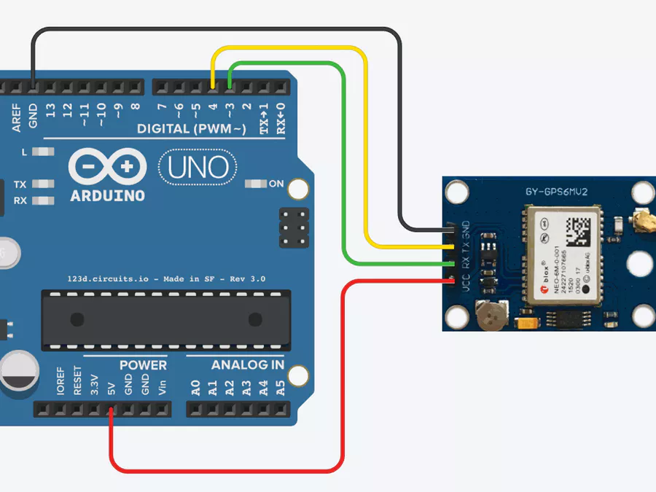

To receive outputs from these sensors we have attatched output sources in our circuits:

1-Buzzer

2-LED

3-Vibrator

1. **Tools and Techniques used (if any) : (5)**

Yes we used a Arduino and a open based Arduino based software to develop codes for different sensors.

In this project we shall be mainly using 5 different types of sensors:

**1-Ultrasonic sensor:** is used for obstacle avoidance. The vibrator vibrates when an obstacle is encountered which helps in alerting the blind person and allows enough time to change their path.

**2-IR sensor**: is used for pit and staircase detection.

**3-Water sensor:**  is used to detect the presence of water and provide an alert in time for path change so as to avoid slipping.

**4-Fire sensor:** is used for avoiding fire.

**5-Light sensor:** is useful at night. It alerts the people in the surrounding area that a blind person is walking and to allow space so that the blind person can walk easily

**6-GPS Module:** is useful to send alerts to family members and nearby police stations.

We also used some **Output devices** such as LED,Buzzer,Vibrator to record the observation.

1. **Details of Algorithms / Designs / Simulations (if any): (15)**

**Design:**

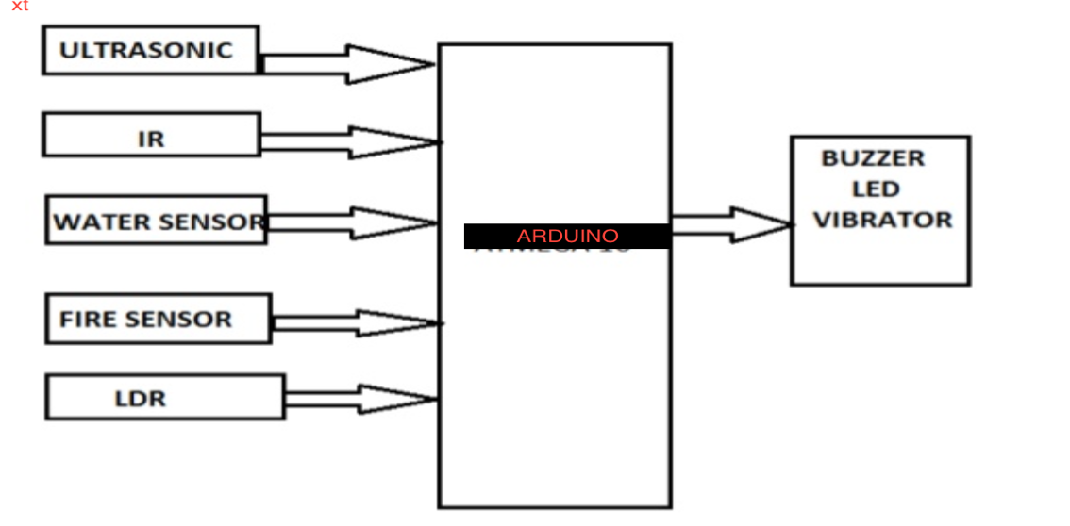

**GPS**

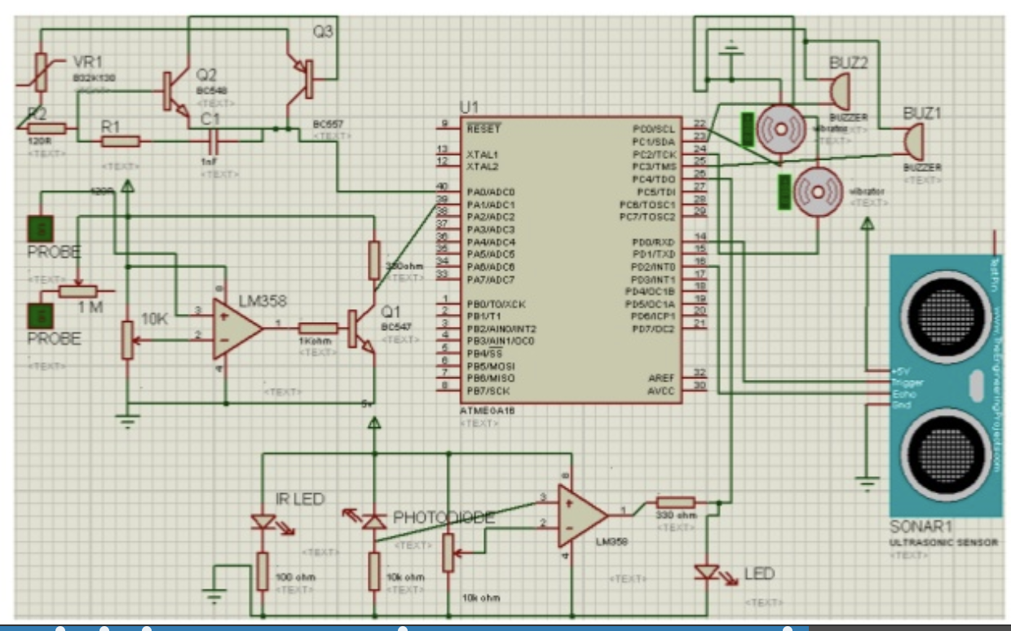

**Algorithms:**

we have written codes for different sensors on open based Arduino and here by attatching the source codes for the above sensors.

ULTRASONIC SENSOR :

**Code snippet**

const int pingPin = 7; // Trigger Pin of Ultrasonic Sensor

const int echoPin = 6; // Echo Pin of Ultrasonic Sensor

void setup() {

Serial.begin(9600); // Starting Serial Terminal

}

void loop() {

long duration, inches, cm;

pinMode(pingPin, OUTPUT);

digitalWrite(pingPin, LOW);

delayMicroseconds(2);

digitalWrite(pingPin, HIGH);

delayMicroseconds(10);

digitalWrite(pingPin, LOW);

pinMode(echoPin, INPUT);

duration = pulseIn(echoPin, HIGH);

inches = microsecondsToInches(duration);

cm = microsecondsToCentimeters(duration);

Serial.print(inches);

Serial.print("in, ");

Serial.print(cm);

Serial.print("cm");

Serial.println();

delay(100);

}

long microsecondsToInches(long microseconds) {

return microseconds / 74 / 2;

}

long microsecondsToCentimeters(long microseconds) {

return microseconds / 29 / 2;

}

FIRE SENSOR:

**Code snippet:**

const int analogPin = A0;    // Flame Sensor (A0) to Arduino analog input pin A0

const int BuzzerPin = 13;       // Buzzer output pin

const int threshold = 400;   // Flame level threshold (You can vary the value depends on your need)

void setup() {

 pinMode(BuzzerPin, OUTPUT);

 // initialize serial communications:

**Serial**.begin(9600);

}

void loop() {

 // read the value of the Flame Sensor:

 int analogValue = analogRead(analogPin);

**Serial**.println(analogValue); //serial print the FLAME sensor value

 if (analogValue > threshold) {

   digitalWrite(BuzzerPin, HIGH);

**Serial**.print("High FLAME");

 }

 else if (analogValue = threshold){

**Serial**.print("Low FLAME");

   digitalWrite(BuzzerPin, HIGH);

   delay(400);

   digitalWrite(BuzzerPin, LOW);

 }

 else {

   digitalWrite(BuzzerPin, LOW);

**Serial**.print("No flame");

 }

 delay(1);

}

**IR SENSOR:**

**Code snippet:**

int LED = 13; // Use the onboard Uno LED

int obstaclePin = 7; // This is our input pin

int hasObstacle = HIGH; // HIGH MEANS NO OBSTACLE

void setup() {

pinMode(LED, OUTPUT);

pinMode(obstaclePin, INPUT);

Serial.begin(9600);

}

void loop() {

hasObstacle = digitalRead(obstaclePin); //Reads the output of the obstacle sensor from the 7th PIN of the Digital section of the arduino

if (hasObstacle == LOW) //LOW means something is ahead, so illuminates the 13th Port connected LED

{

Serial.println("Stop something is ahead!!");

digitalWrite(LED, HIGH);//Illuminates the 13th Port LED

}

else

{

Serial.println("Path is clear");

digitalWrite(LED, LOW);

}

delay(200);

}

**WATER SENSOR:**

**Code snippet:**

#define Grove_Water_Sensor 8 // Attach Water sensor to Arduino Digital Pin 8

#define LED 9 // Attach an LED to Digital Pin 9 (or use onboard LED)

void setup() {

pinMode(Grove_Water_Sensor, INPUT); // The Water Sensor is an Input

pinMode(LED, OUTPUT); // The LED is an Output

}

void loop() {

/* The water sensor will switch LOW when water is detected.

Get the Arduino to illuminate the LED and activate the buzzer

when water is detected, and switch both off when no water is present */

if( digitalRead(Grove_Water_Sensor) == LOW) {

digitalWrite(LED,HIGH);

}else {

digitalWrite(LED,LOW);

}

}

**LIGHT SENSOR:**

**Code snippet:**

const int ledPin = 13;

const int ldrPin = A0;

void setup() {

Serial.begin(9600);

pinMode(ledPin, OUTPUT);

pinMode(ldrPin, INPUT);

}

void loop() {

int ldrStatus = analogRead(ldrPin);

if (ldrStatus <= 200) {

digitalWrite(ledPin, HIGH);

Serial.print("Its DARK, Turn on the LED : ");

Serial.println(ldrStatus);

} else {

digitalWrite(ledPin, LOW);

Serial.print("Its BRIGHT, Turn off the LED : ");

Serial.println(ldrStatus);

}

}

**GPS MODULE:**

**Code snippet:**

#include <LiquidCrystal.h>

#include <SoftwareSerial.h>

#include <TinyGPS.h>

//long lat,lon; // create variable for latitude and longitude object

float lat = 28.5458,lon = 77.1703; // create variable for latitude and longitude object

SoftwareSerial gpsSerial(3,4);//rx,tx

LiquidCrystal lcd(A0,A1,A2,A3,A4,A5);

TinyGPS gps; // create gps object

void setup(){

Serial.begin(9600); // connect serial

//Serial.println("The GPS Received Signal:");

gpsSerial.begin(9600); // connect gps sensor

lcd.begin(16,2);

}

void loop(){

while(gpsSerial.available()){ // check for gps data

if(gps.encode(gpsSerial.read()))// encode gps data

{

gps.f_get_position(&lat,&lon); // get latitude and longitude

// display position

lcd.clear();

lcd.setCursor(1,0);

lcd.print("GPS Signal");

//Serial.print("Position: ");

//Serial.print("Latitude:");

//Serial.print(lat,6);

//Serial.print(";");

//Serial.print("Longitude:");

//Serial.println(lon,6);

lcd.setCursor(1,0);

lcd.print("LAT:");

lcd.setCursor(5,0);

lcd.print(lat);

//Serial.print(lat);

//Serial.print(" ");

lcd.setCursor(0,1);

lcd.print(",LON:");

lcd.setCursor(5,1);

lcd.print(lon);

}

}

String latitude = String(lat,6);

String longitude = String(lon,6);

Serial.println(latitude+";"+longitude);

delay(1000);

}

1. **Important Results Obtained: (10)**

The project proposed the design and architecture of a new concept of Smart Electronic Arduino based navigator for differently-abled people. The advantage of the system lies in the fact that it can prove to be very low cost solution to millions of differently-abled person worldwide. The proposed combination of various working units makes a real-time system that monitors position of the user and provides dual feedback making navigation more safe and secure. It can be further improved to have more decision taking capabilities by employing varied types of sensors and thus could be used for different applications. It aims to solve the problems faced by the differently-abled people in their daily life. The system also takes measures to ensure their safety.

**Further Advancements which can be applied on project:**

It can be further enhanced by using VLSI technology to design the PCB unit. This makes the system further more compact. Also,use of active RFID tags will transmit the location information automatically to the PCB unit, when the intelligent stick is in its range. The RFID sensor doesn't have to read it explicitly.The global position of the user is obtained using the global positioning system(GPS),and their current position and guidance to their destination will be given to the user by voice



(**Signature)**

**Priyansh Aryan**

**Team Lead**